**PLCnext Engineer**

**EHMI**

**Editing a Symbol**

Table of Contents

1. Overview

2. General Information

3. Instructions to edit a existing Symbol

# Overview

1. Editing an existing HMI symbol

2. We will change the standard color and make it selectable.

3. We will use the Bar Graph

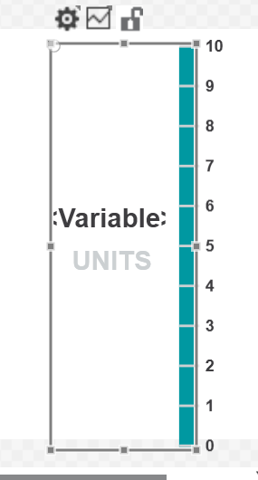

# 2. General Information

**1. We want to change the fixed standard color of the Bar Graph.**

**2. PLC Next Engineer software HMI Symbols**

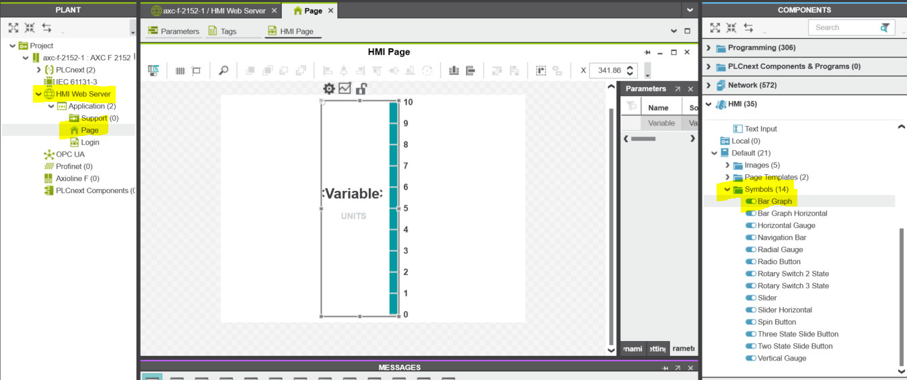

# Instructions

1. To edit existing symbol. You go to the symbol under HMI – Default – Symbols.
2. Pick the symbol and right click and copy.
3. For this example, we will use Bar Graph. Right click and copy.



Right Click Copy

1. Now go to HMI-Local- Symbols and right click paste.
2. IMPORANT STEP once the symbol is now in your list you need to right click and rename.

The name I used here is Bar Color

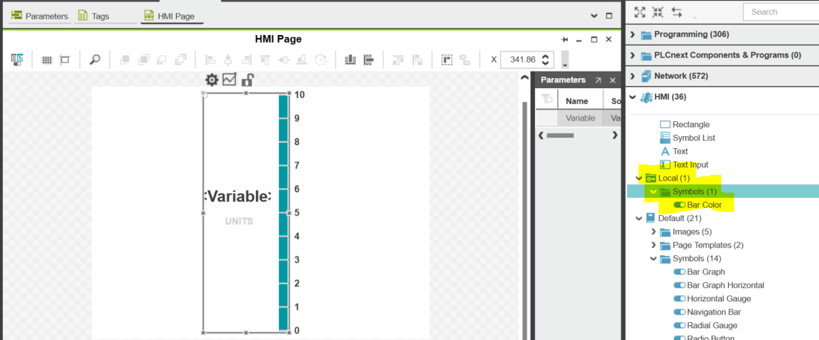

Right click Symbols Paste

Right Click Rename

1. Double click your symbol you just renamed. It will open and you can make edits and then it will be saved, and you can use it in your program.

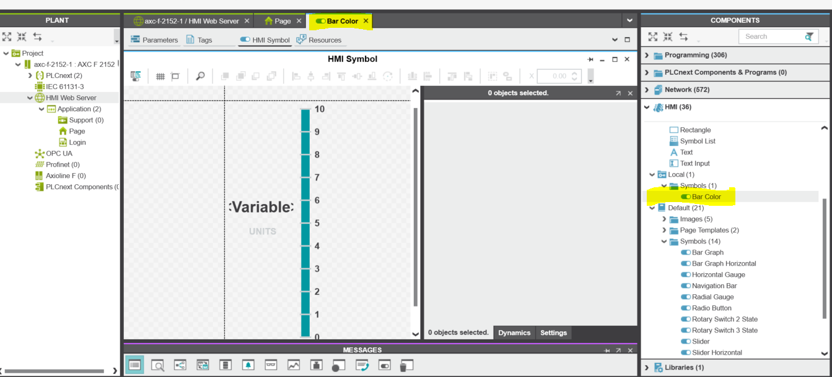

1. You can Change the Background color and make it a fixed color or you can make it selectable.
2. Once the Symbol is opened you will see the screen below. Click on settings and scroll up and down to see the options.
3. This symbol we will click on numbers and move right with arrow keys. Click on teal Bar and move left with arrows. You now have the 3 different objects we can work on changing.
4. To change the Background color of the bar you can select the object then color.

With this symbol there are multiple bars. (see below Bar and Bar Background)

Note: you may also need to change the color of (Scale.Properties.Stroke) depending on which color you choose.

1. To make this Selectable in the programming you need to select the object and them Right click on the word Fill. Select Add “Fill” as symbol setting.

The 3 objects.

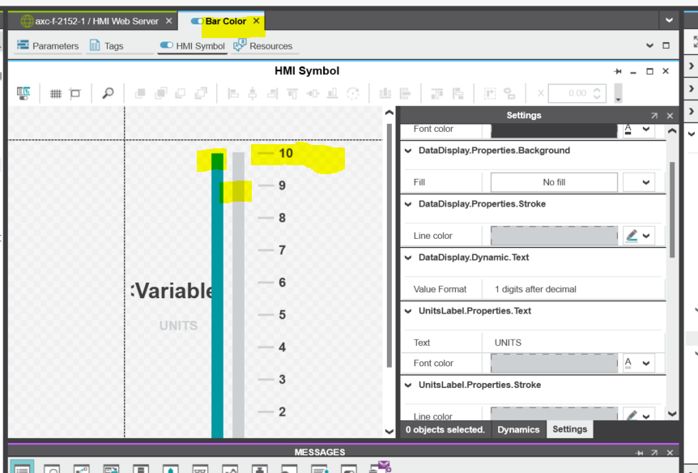

Bar Background

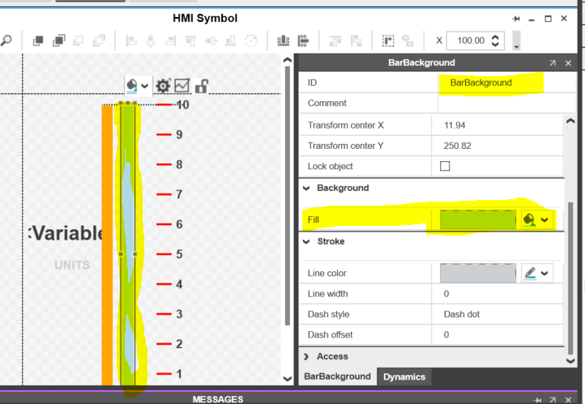

Bar

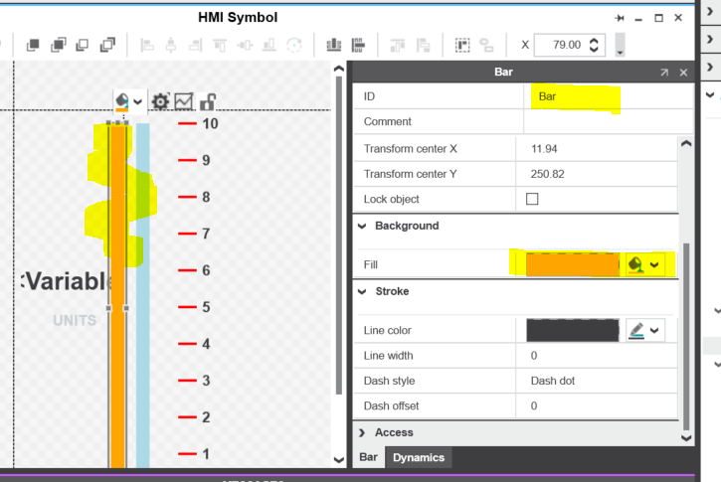

1. In this example we will change the Color to blue (Bar) We will leave the Bar Back ground Grey. Also we will change the Scale1 object to Black 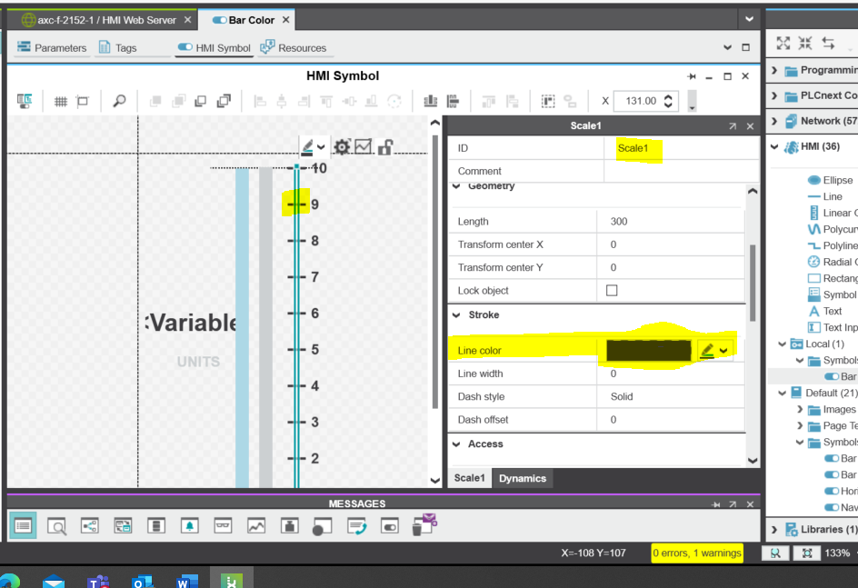
2. Reassemble the symbol by moving items left and right.
3. **Close out the Bar Color Tab at the top. Open your HMI page on the left and then drag your new symbol onto the page.**

**If you made the color selectable you will see the option under settings.**

